West Coast

Contact Tourism West Coast , www.westcoast.co.nz for information on this area.

Okarito, breeding colony for white heron (in season).

Fox and Franz Josef Glaciers, walk to the ice faces.

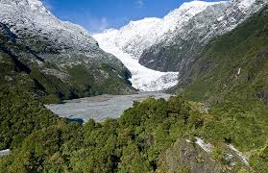

Punakaiki spectacular pancake rocks, blow holes, excellent viewing.
Best at high tide and even better in rough weather.
Paparoa National Park Visitor Centre www.punakaiki.co.nz

Westport, excellent accommodation available.
Westport Visitor Information Centre, 03 789 6658.

